|  |  |  |
| --- | --- | --- |
| **Year 11 Essentials** Mini Test 1.4Volume and Capacity Name:________________ | | |
| Resources to be provided by the student: Calculator, a single sided A4 page of notes, ruler, pens, pencils Time: 20min |  | Total: /18  Weighting: 1% |

1. [4 marks]

Choose an appropriate unit of measurement to describe the volume of the following items.

|  |  |  |  |
| --- | --- | --- | --- |
| a) | Refrigerator | b) | Moving box |
|  |  |  |  |

|  |  |  |  |
| --- | --- | --- | --- |
| c) | Takeaway food container | d) | Car |

1. [4 marks]

Calculate the volume of the following 3D objects

a) A cube with edges of length 5cm b)

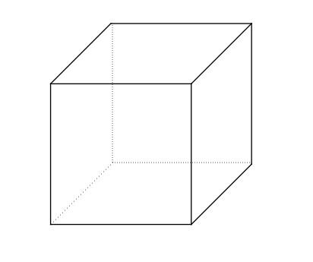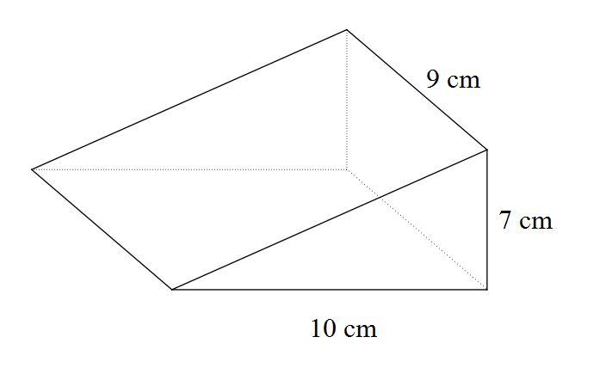

1. [4 marks]

Determine the capacity of the objects in Question 2 in millilitres and litres.

1. [6 marks]

A fish tank has rectangular sides made of glass. It is 120 cm long and 70 cm wide. The water is 42 cm deep.

1. Sketch a diagram depicting this information.
2. How many cubic centimeters of water does the fish tank contain?
3. If each litre of water occupies 1000 cm3, how many litres does the tank contain?